Gymnastics Invite**

**Perham High School**

**800 Coney St W.**

**Perham, Mn. 56573**

**Gymnastic Meet Information**

*Meet Date:* *VARSITY/JV COMPETITION*

Saturday, December 7th, 2024

*Meet Site:* New Perham High School 800 Coney St W Perham

*Teams Enter:* Door 2

*Teams Competing:* Cambridge-Isanti

Detroit Lakes

Fergus Falls

Perham

Minnetonka

St Michael/Albertville

Watertown-Mayer/Mound Westonka

Melrose

*Gym Opens:* 7:30am

*Team Rotation:* rotation sheet is enclosed

*Open Warmups:* 7:30-9:00 a.m. plus Bar Settings at this time on your own

*Timed Warmups:* 9:00-11:40 a.m. 20 minutes per warmup + 1 minute switch time is included in the 20 minutes

*Officials & Coaches Meeting:* There will be an officials/coaches meeting after the warm-up period at 11:40

*March In:* 12:00 a.m.

*Competition:* 12:15 p.m. (Varsity 5 per event JV 7 per event)

**Vault** the JV will get a 3-minute touch and compete then the Varsity will get a 3-minute touch and compete.

**Beam, Bars** **and Floor** teams will combine their Varsity and JV and split them in into 2 groups each group will have a 3-minute warm up and compete alternating JV and Varsity in their group.

*Touch Warmup:* There will be a 3-minute touch warm-up per event

*Officials:*  Official (1 Varsity per event and 1 JV per event)

*Roster:* Please e-mail a Varsity/JV team roster with a list of the coaching staff by *Monday, November 25st* to Mike Peterson mpeterson@perham.k12.mn.us

*Questions call:*  Assistant Coach Mike Peterson (218) 849-8466

mpeterson@perham.k12.mn.us

Activities Director Erin Anderson (218) 346-1610

eanderson@perham.k12.mn.us

*Awards:* Meet Results and Event place winners

Medals – 1-8 places Varsity

Ribbons-1-8 places JV

To have an All Around score a gymnast must compete either completely JV or Varsity

*Equipment Available:* Floor Exercise 45x45 carpeted spring floor

AAI Elite Uneven Bars

AAI Reflex Balance Beam

AAI Vaulting Table (please bring your own vaulting board)

Music – IPod, Cell Phone Plug In Available

*Concessions:* Will be available

*Locker Room:* A locker room area will be available for all but

it is suggested to have a bag for all of your valuables and belongings.

*Entry Fees:*  $200.00 per team

Make checks payable to Perham Activities

800 Coney St. West, Perham, MN 56573

Attn: Erin Anderson

*Motel:* Grandstay, Perham - (218) 346-2033

Good Luck Gymnasts!

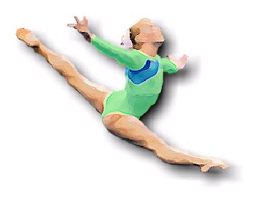

**Jackie Mann Invite Apparel Information**

Here is the Link <https://jackiemann24.itemorder.com/> This will take you directly to the store.  All the details are listed when you click on the link, pricing, sizing etc. This is a fundraiser for our team.

Please place your order as soon as possible as this store will close promptly at **Noon on this Tuesday November 26th**  Your orders will be ready for pick up at the Jackie Mann Gymnastics Invite on Dec 7th, 2024.